**PROFESSIONAL INTERNSHIP REPORT**

**ON**

**“RESTAURANT MANAGEMENT SYSTEM”**

**AT**

**KAASHIV INFOTECH PVT**

**CHENNAI**

**AN INDUSTRY INTERNSHIP REPORT SUBMITTED**

**IN PARTIAL FULFILLMENT OF THE REQUIREMENTS**

**FOR THE AWARD** **OF DEGREE OF**

**BACHELOR OF ENGINEERING**

**In**

**Department of Computer Science and Engineering**

**SUBMITTED BY**

SNOWBER HAMID

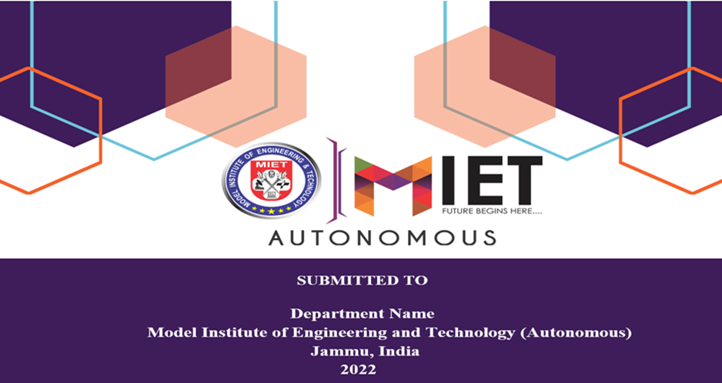 Roll Number: (2020a1r065)

**CANDIDATES’ DECLARATION**

I, SNOWBER HAMID Roll Number (2020a1r065) hereby declare that the work which is being

presented in the Industry Internship Report entitled, “RESTAURANT MANAGEMENT

SYSTEM” in partial fulfillment of requirement for the award of degree of B.E. (COMPUTER

SCIENCE & Engineering) and submitted in the Department of Computer Science And

Engineering, Model Institute of Engineering and Technology (Autonomous), Jammu is an

authentic record of my own work carried by me at “KAASHIV INFOTECH PVT” under the

supervision and mentorship of VENKATESAN PRABU.J(MANAGING DIRECTOR). The

matter presented in this report has not been submitted in this or any other University / Institute

for the award of B.E. Degree.

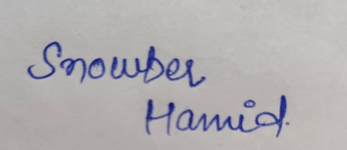

*Signature of the Student* *Dated:*

**(SNOWBER HAMID)** 09th nov 2022

**(2020A1R065)**

**INTERNSHIP CERTIFICATE**

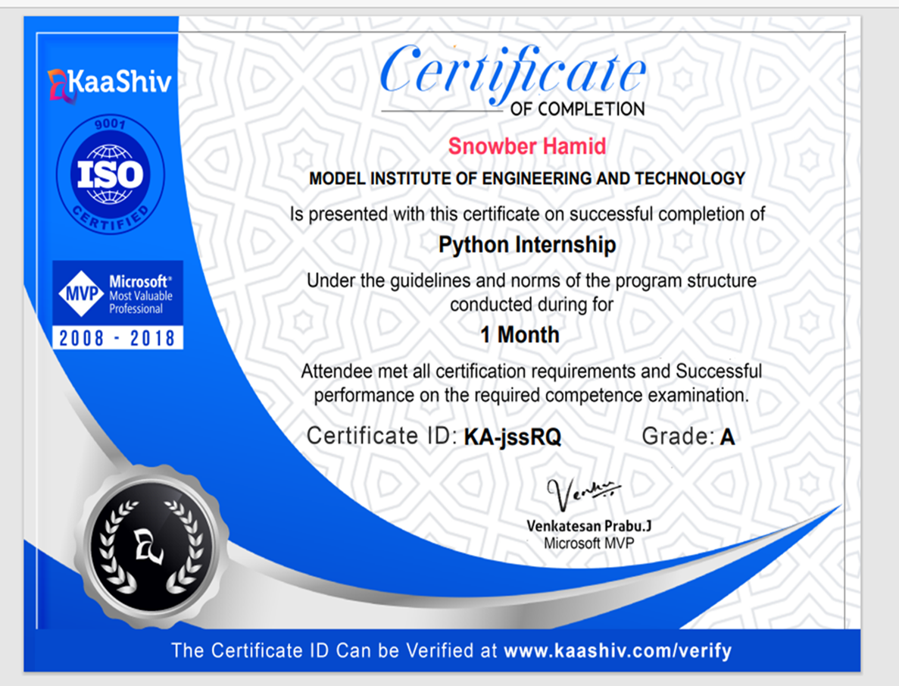

**Department Of Computer Science and Engineering**

**Model Institute of Engineering and Technology (Autonomous)**

**Kot Bhalwal, Jammu, India**

***(NAAC “A” Grade Accredited)***

**Ref. No.:2020A1R065** **Date:9TH NOV 2022**

**CERTIFICATE**

Certified that this Industry Internship Report entitled **“RESTAURANT MANAGEMENT SYSTEM”** is the bonafide work of “**SNOWBER HAMID, Roll No 2020A1R065, of 5th Semester, Department of Computer Science and Engineering, Model Institute of Engineering and Technology (Autonomous), Jammu”,** who carried out the industryInternship at “**KAASHIV INFOTECH PVT**” work under my mentorship during 15th July,2022 to 15th August, 2022.

**MS. VEENA TRIPATHI**

**Assistant professor**

**CSE, MIET**

*This is to certify that the above statement is correct to the best of my knowledge.*

**Prof. (Dr.) Ashok Kumar**

**Dean Academic Affairs &**

**Head of the Department**

**CSE, MIET**

**ACKNOWLEDGEMENTS**

The summer internship opportunity I had with KAASHIV INFOTECH PVT provide me a great chance for learning and professional development. I am grateful for having a chance to meet so many wonderful people and professionals who led me though this internship period. It is my pleasant duty to pay my heartfelt gratitude to Mr. Venkatesan Prabu. J, Managing Director Kaashiv Infotech Pvt who have guided me through the course of this Internship.

I must record my deep sense of gratitude to Prof. (Dr.) Ankur Gupta (Director, MIET) and Prof. (Dr.) Ashok Kumar (Dean Academics &amp; HOD CSE, MIET) for their guidance, constant inspiration and encouragement, and for their keen involvement throughout the course of present work.

Gratitude and thanks although mean a very small thing to convey my thanks to my parents who have always given me a parental source of love, motivation and strength right from the journey of my life.

Bearing in mind previous I am using this opportunity to express my deepest gratitude and special thanks to the teachers who in spite of being extraordinarily busy with their duties, took time out to hear, guide and keep me on the correct path and allowing me to carry out my project at their esteemed organization and extending during the internship.

I perceive this opportunity as a big milestone in my career development. I will strive to use gained skills and knowledge in the best possible way, and I will continue to work on their improvement, in order to attain desired career objectives. Hope to continue cooperation with all of you in the future.

I express my sincere gratitude KAASHIV INFOTECH PVT, Chennai and Model Institute

of Engineering and Technology (Autonomous), Jammu for giving me the opportunity.

**SNOWBER HAMID**

**(2020A1R065)**

**CONTENTS PAGE NO.**

Candidate’s Declaration 2

Internship Certificate 3

Certificate 4

Acknowledge 5

Chapter-1 **INTRODUCTIO TO PYTHON**

1.1 Introduction 10-13

* 1. History of python 14-15
  2. Need of python 16-18
  3. Applications of python 19-26

Chapter-2 **TKINTER**

3.1 Introduction to Tkinter 26-27

3.2 Advantages of Tkinter 27-28

3.3 Disadvantages of Tkinter 29

Chapter-3  **IMPLEMENTATION**

4.1 Technologies used 30

4.2 Language used 30

4.3 Code of the project 30-42

Chapter-5 **CONCLUSION** 43

**REFERENCES 44**

**LIST OF FIGURES**

FIGURES PAGE NO.

fig;(1) 10

fig;(2) 12

fig;(3) 15

fig;(4) 21

fig;(5) 22

fig;(6) 23

fig;(7) 24

fig;(8) 26

fig;(9) 29

**CHAPTER-1:**

**INTRODUCTION TO PYTHON**

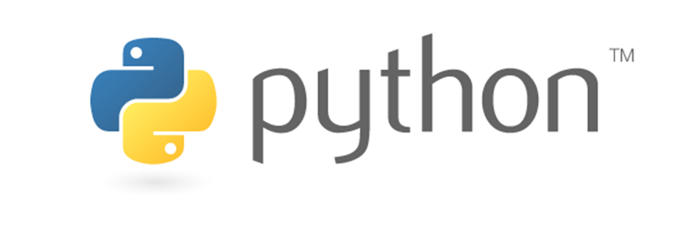

fig;(1)

Just like we use Hindi or English to communicate with each other, similarly we use a Programming language to communicate with the computer. Programming is a way to instruct the computer to perform various tasks.

Python is a widely used general-purpose, high level and popular programming language. Python is a programming language that lets you work quickly and integrate systems more efficiently.

* Python was designed for readability, and has some similarities to the English language with influence from mathematics
* Python uses new lines to complete a command, as opposed to other programming languages which often use semicolons or parentheses.
* Python relies on indentation, using whitespace, to define scope; such as the scope of loops, functions and classes. Other programming languages often use curly-brackets for this purpose.
* Python supports multiple programming paradigms, including Procedural, Object Oriented and Functional programming language.

Python is a dynamic, interpreted (bytecode-compiled) language. There are no type declarations of variables, parameters, functions, or methods in source code. This makes the code short and flexible, and you lose the compile-time type checking of the source code. Python tracks the types of all values at runtime and flags code that does not make sense as it runs.

Python is derived from many other languages, including ABC, Modula-3, C, C++, Algol-68, Small Talk, and Unix shell and other scripting languages. Python is copyrighted. Like Perl, Python source code is now available under the GNU General Public License (GPL).

Python is now maintained by a core development team at the institute, although Guido van Rossum still holds a vital role in directing its progress

An excellent way to see how Python code works is to run the Python interpreter and type code right into it. If you ever have a question like, "What happens if I add an int to a list?" Just typing it into the Python interpreter is a fast and likely the best way to see what happens. (See below to see what really happens)

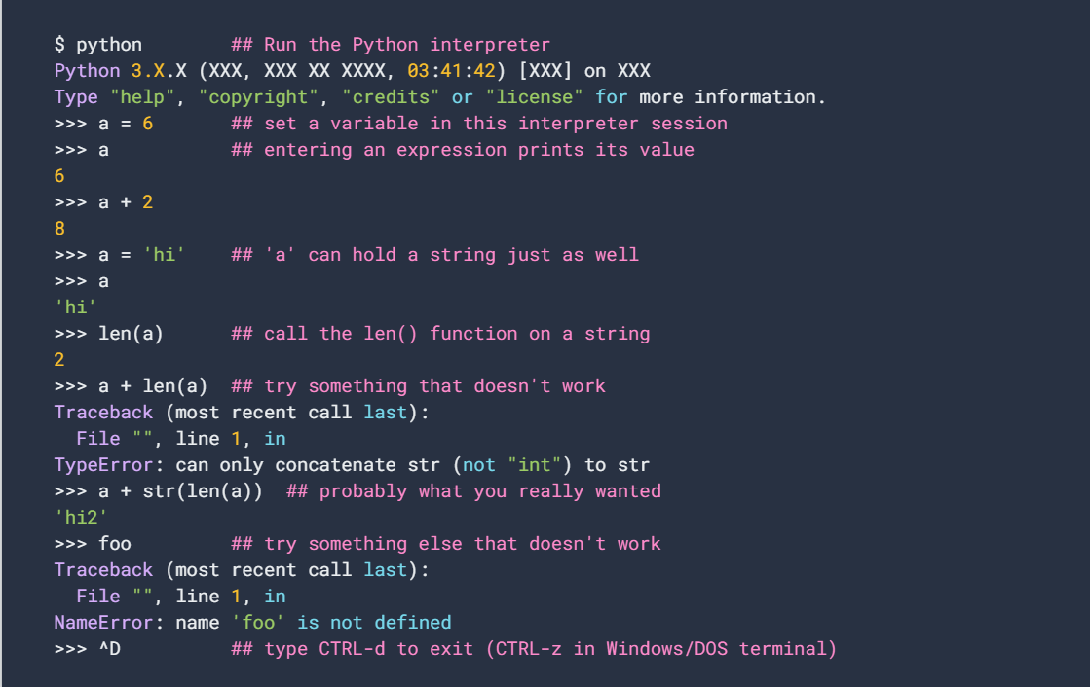

fig;(2)

The two lines python prints after you type python and before the >>> prompt tells you about the version of python you're using and where it was built. As long as the first thing printed is "Python 3."

**HISTORY OF PYTHON** illustrations of different versions of Python along with the timeline.

In the late 1980s, history was about to be written. It was that time when working on Python started. Soon after that, Guido Van Rossum began doing its application-based work in December of 1989 at Centrum Wiskunde & Informatica (CWI) which is situated in the Netherlands. It was started firstly as a hobby project because he was looking for an interesting project to keep him occupied during Christmas. The programming language in which Python is said to have succeeded is ABC Programming Language, which had interfacing with the Amoeba Operating System and had the feature of exception handling. He had already helped to create

ABC earlier in his career and he had seen some issues with ABC but liked most of the features. After that what he did was really very clever. He had taken the syntax of ABC, and some of its good features. It came with a lot of complaints too, so he fixed those issues completely and had created a good scripting language that had removed all the flaws. The inspiration for the name came from

BBC’s TV Show – ‘Monty Python’s Flying Circus’, as he was a big fan of the TV show and also he wanted a short, unique and slightly mysterious name for his invention and hence he named it Python! He was the “Benevolent dictator for life” (BDFL) until he stepped down from the position as the leader on 12th July 2018.

For quite some time he used to work for Google, but currently, he is working at Dropbox. The language was finally released in 1991. When it was released, it used a lot fewer codes to express the concepts, when we compare it with Java, C++ & C. Its design philosophy was quite good too. Its main objective is to provide code readability and advanced developer productivity. When it was released, it had more than enough capability to provide classes with inheritance, several core data type exception handling and functions.

fig;(3)

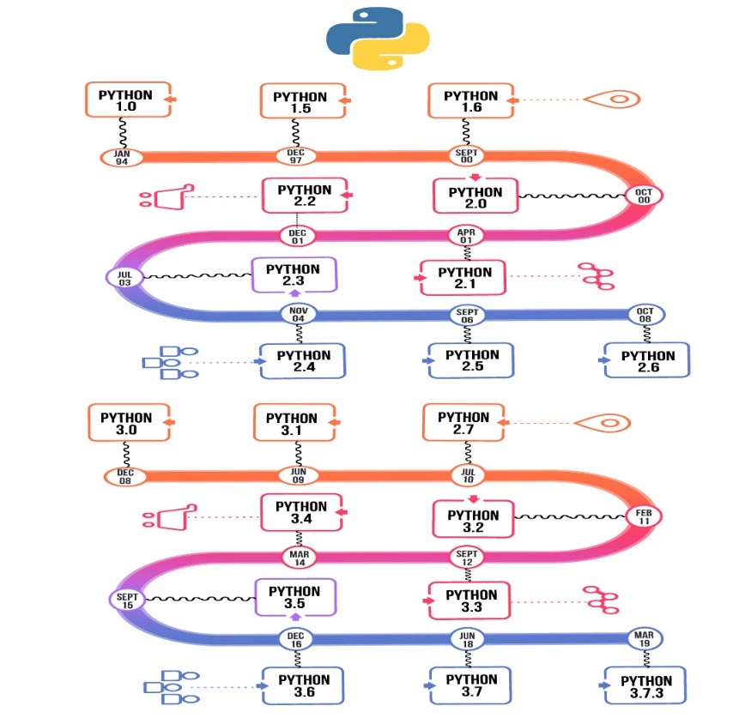

**NEED OF PYTHON**

Python is commonly used for developing websites and software, task automation, data analysis, and data visualization. Since it’s relatively easy to learn, Python has been adopted by many non-programmers such as accountants and scientists, for a variety of everyday tasks, like organizing finances.

* Data analysis and machine learning
* Web development
* Automation or scripting
* Software testing and prototyping
* Everyday tasks

**Data analysis and machine learning:**

Python has become a staple in data science, allowing data analysts and other professionals to use the language to conduct complex statistical calculations, create data visualizations, build machine learning algorithms, manipulate and analyse data, and complete other data-related tasks.

Python can build a wide range of different data visualizations, like line and bar graphs, pie charts, histograms, and 3D plots. Python also has a number of libraries that enable coders to write programs for data analysis and machine learning more quickly and efficiently, like TensorFlow and Keras.

**Web Development:**

Python is often used to develop the back end of a website or application—the parts that a user doesn’t see. Python’s role in web development can include sending data to and from servers, processing data and communicating with databases, URL routing, and ensuring security. Python offers several frameworks for web development. Commonly used ones include Django and Flask.

Some web development jobs that use Python includebackend engineers, full stack engineers, Python developers, software engineers, and DevOps engineers.

**Automation or scripting:**

If you find yourself performing a task repeatedly, you could work more efficiently by automating it with Python. Writing code used to build these automated processes is called scripting. In the coding world, automation can be used to check for errors across multiple files, convert files, execute simple math, and remove duplicates in data.

Python can even be used by relative beginners to automate simple tasks on the computer—such as renaming files, finding and downloading online content or sending emails or texts at desired intervals

**Software testing and prototyping:**

In software development, Python can aid in tasks like build control, bug tracking, and testing. With Python, software developers can automate testing for new products or features. Some Python tools used for software testing include Green and Requestium.

**Everyday tasks:**

Python isn't only for programmers and data scientists. Learning Python can open new possibilities for those in less data-heavy professions, like journalists, small business owners, or social media marketers. Python can also enable non-programmers to simplify certain tasks in their lives. Here are just a few of the tasks you could automate with Python:

* Keep track of stock market or crypto prices
* Send yourself a text reminder to carry an umbrella anytime it’s raining
* Update your grocery shopping list
* Renaming large batches of files
* Converting text files to spreadsheets
* Randomly assign chores to family members
* Fill out online forms automatically

**APPLICATIONS OF PYTHON**

Python is used in many application domains.

**1. Web and Internet Development:**

Python offers many choices for web development:

* Frameworks such as **Django** and **Pyramid.**
* Micro-frameworks such as **Flask** and **Bottle.**
* Advanced content management systems such as **Plone** and **Django CM**

Python's standard library supports many Internet protocols:

* **HTML** and **XML**
* **JSON**
* Email Processing
* Support for **FTP, IMAP**, **Internet protocols**.
* Easy to use **Socket Interface**.

**2**. **Scientific and Numeric**:

Python is widely used in computing and numeric:

* Scipy is a collection of packages for mathematics, science, and engineering
* Pandas is a data analysis and modeling library.
* IPython is a powerful interactive shell that features easy editing and recording of a work session, and supports visualizations and parallel computing.

**3. Audio and visual applications:**

Audio and video are undoubtedly the most amazing application of python. Python is equipped with a lot of tools and libraries. Python is equipped with a lot of tools and libraries to accomplish your task flawlessly. Applications that coded in python include popular ones like **Netflix, Spotify, You Tube.** This can be handled by libraries like:

* OpenCV
* Scipy
* Mingus
* Pyo
* Dejavu

fig;(4)

**4**. **Operating system:**

The robust standard library of Python makes it perfect for building entire operating systems. The object-oriented design of the language ensures large projects are easily managed. Python is compatible with most operating systems and can be easily used to build native applications for Windows and Mac computers.

**5.** **Desktop GUI:**

Python is an excellent choice for desktop GUI (Graphical User Interface) programming. The language offers numerous options for developers to build a fully functional GUI. The comprehensive syntax and modular programming approach of the Python framework help create a super-fast and responsive GUI.

Some prominent **applications of Python** tools for GUI development are PyQt, Tkinter, wxWidgets, Python GTK+, and Kivy. Standard applications like Dropbox and BitTorrent are primarily written in Python.

Fig;(5)

**6**. **Game Development:**

Just like for web development, Python offers an array of tools and libraries for game development. Would you believe, Battlefield 2 – one of the most popular shooting games of the early 2000s, was developed with the **use of Python**.

Python’s 2D and 3D game development libraries are PyGame, Pycap, Panda#D, Construct, PySoy, and PyOpenGL.

Python has been used to develop popular games, including Sims 4, World of Tanks, Eve Online, Mount & Blade, Doki Doki Literature Club, and Disney’s Toontown Online, to name a few.

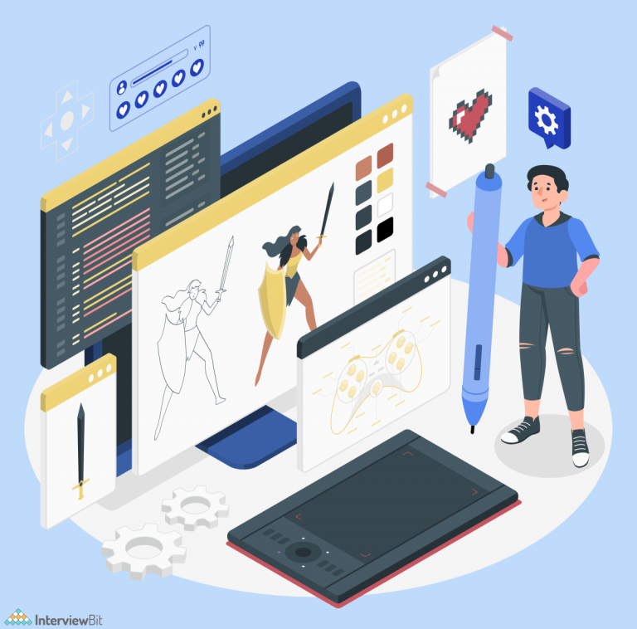fig;(6)

**7.** **Artificial Intelligence and Machine learning:**

The hottest buzzwords of the decade – Artificial Intelligence (AI) and Machine Learning are mostly about algorithms, code, and logic. Python, along with a few other programming languages, is increasingly being used for developing AI and ML-powered solutions. The scope and power of Python, along with its stability and security, make it ideal for running AI and ML systems.

fig;(7)

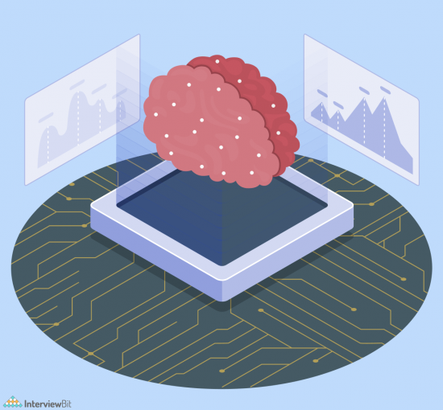

**8. Business Applications:**

**Applications of Python** also include building ERP and ecommerce systems. Business applications are different from typical consumer software because they offer a set of specific features instead of a variety of features. Besides, they target a very tight-knit user group, usually an organization.

Python is perfect for delivering best-performance custom solutions for business applications as well as consumer applications.

Odoo is a well-rounded management software that offers numerous business applications that constitute a complete set of enterprise management applications

Tryton is a three-tier high-level application platform designed for general purposes.



fig;(8)

**CHAPTER - 2**

**TKINTER**

Tkinter is an open source, portable graphical user interface (GUI) library designed for use in Python scripts.  
Tkinter relies on the Tk library, the GUI library used by Tcl/Tk and Perl, which is in turn implemented in C. Therefore, Tkinter can be said to be implemented using multiple layers.  
Several competing GUI toolkits are available to use with the Python language, namely:

* **wxPython:** a wrapper extension for wxWindows, a portable GUI library originally developed for the C++ language. It is the second most popular GUI toolkit for Python since it is considered excellent for complex interface design.
* **JPython (Jython):** since it is implemented in java, JPython has access to Java GUI libraries, namely SWING and AWT. Recently, JTkinter has been implemented and provides a Tkinter port to JPython using the Java Native Interface (JNI).
* **PyKDE / PyQt, PyGTK:** these packages provide an access to KDE and Gnome GUI libraries to python scripts.
* **Win32all.exe:** provides access to Microsoft Foundation Classes (MFC) to python scripts. It is limited to run on MS Windows only.
* **WPY:** a GUI library that can be used on both Microsoft Windows and UNIX X Windows. This library uses the MFC coding style.
* **X11:** a library based on the X Windows and Motif libraries allowing excellent control of the X11 environment, but are limited to run on X Windows OS’s only

**ADVANTAGES OF TKINTER:**

1. **Layered Approach:**

The layered approach used in designing Tkinter gives Tkinter all of the advantages of the TK library. Therefore, at the time of creation, Tkinter inherited from the benefits of a GUI toolkit that had been given time to mature. This makes early versions of Tkinter a lot more stable and reliable than if it had been rewritten from scratch. Moreover, the conversion from Tcl/Tk to Tkinter is really trivial, so that Tk programmers can learn to use Tkinter very easily.

1. **Accessibility**:

Learning Tkinter is very intuitive, and therefore quick and painless. The Tkinter implementation hides the detailed and complicated calls in simple, intuitive methods. This is a continuation of the Python way of thinking, since the language excels at quickly building prototypes. It is therefore expected that its preferred GUI library be implemented using the same approach. For example, here is the code for a typical “Hello world”-like application:

From Tkinter import *  
root = Tk( )  
root.title("A simple application")  
root.mainloop( )

The first 2 lines allow to create a complete window. Compared to MFC programming, it makes no doubt that Tkinter is simple to use. The third line sets the caption of the window, and the fourth one makes it enter its event loop.

1. **Portability:**

Python scripts that use Tkinter do not require modifications to be ported from one platform to the other. Tkinter is available for any platform that Python is implemented for, namely Microsoft Windows, X Windows, and Macintosh. This gives it a great advantage over most competing libraries, which are often restricted to one or two platforms. Moreover, Tkinter will provide the native look-and-feel of the specific platform it runs on.

1. **Availability:**

Tkinter is now included in any Python distribution. Therefore, no supplementary modules are required in order to run scripts using Tkinter.

**DISADVANTAGES OF TKINTER:**

The multi-layered approach taken in designing Tkinter can have some disadvantages as far as execution speed is concerned. While this could constitute a problem with older, slower machines, most modern computers are fast enough so as to cope with the extra processing in a reasonable time. When speed is critical, proper care must be taken so as to write code that is as efficient as possible

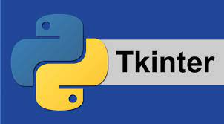fig;(9)

**CHAPTER – 3**

**IMPLEMENTATION**

Technologies used **– 3.10.5**

**Python Tkinter GUI**

Language used – Python

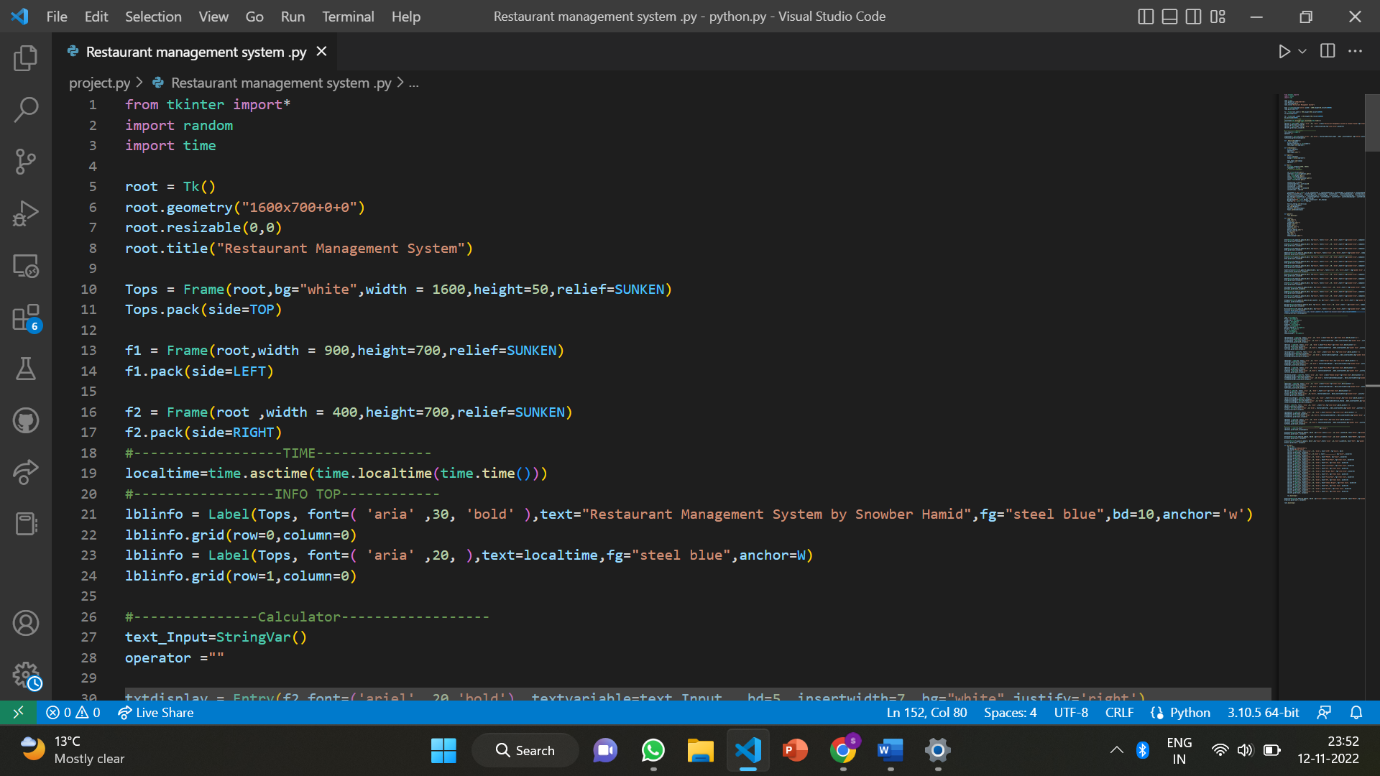**CODE OF PROJECT:**

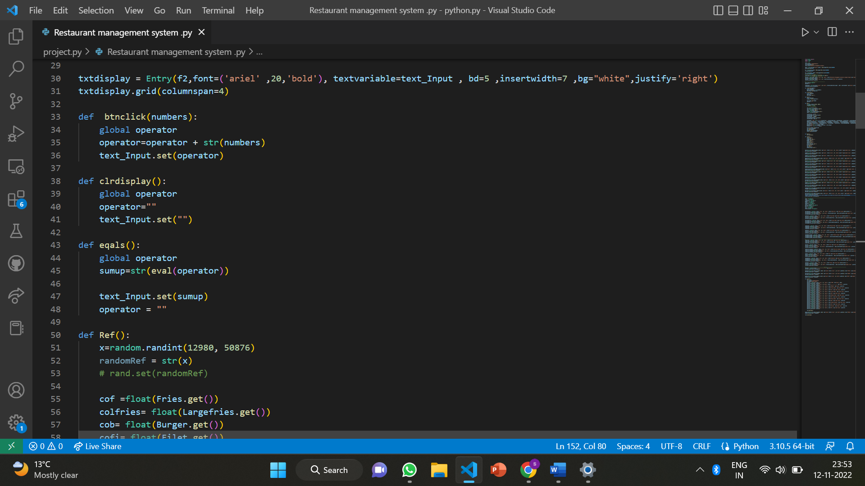

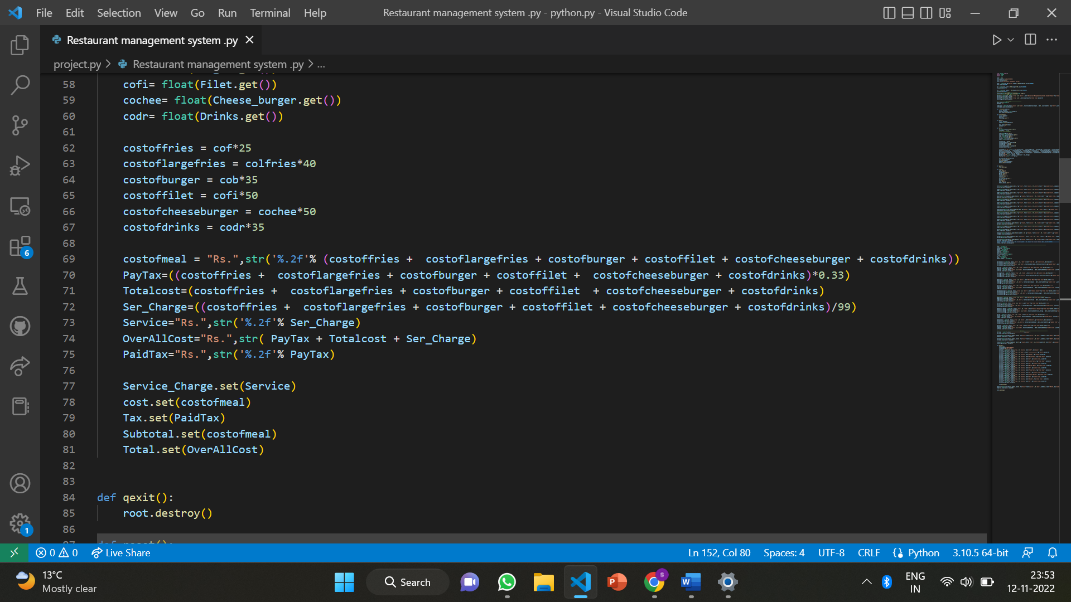

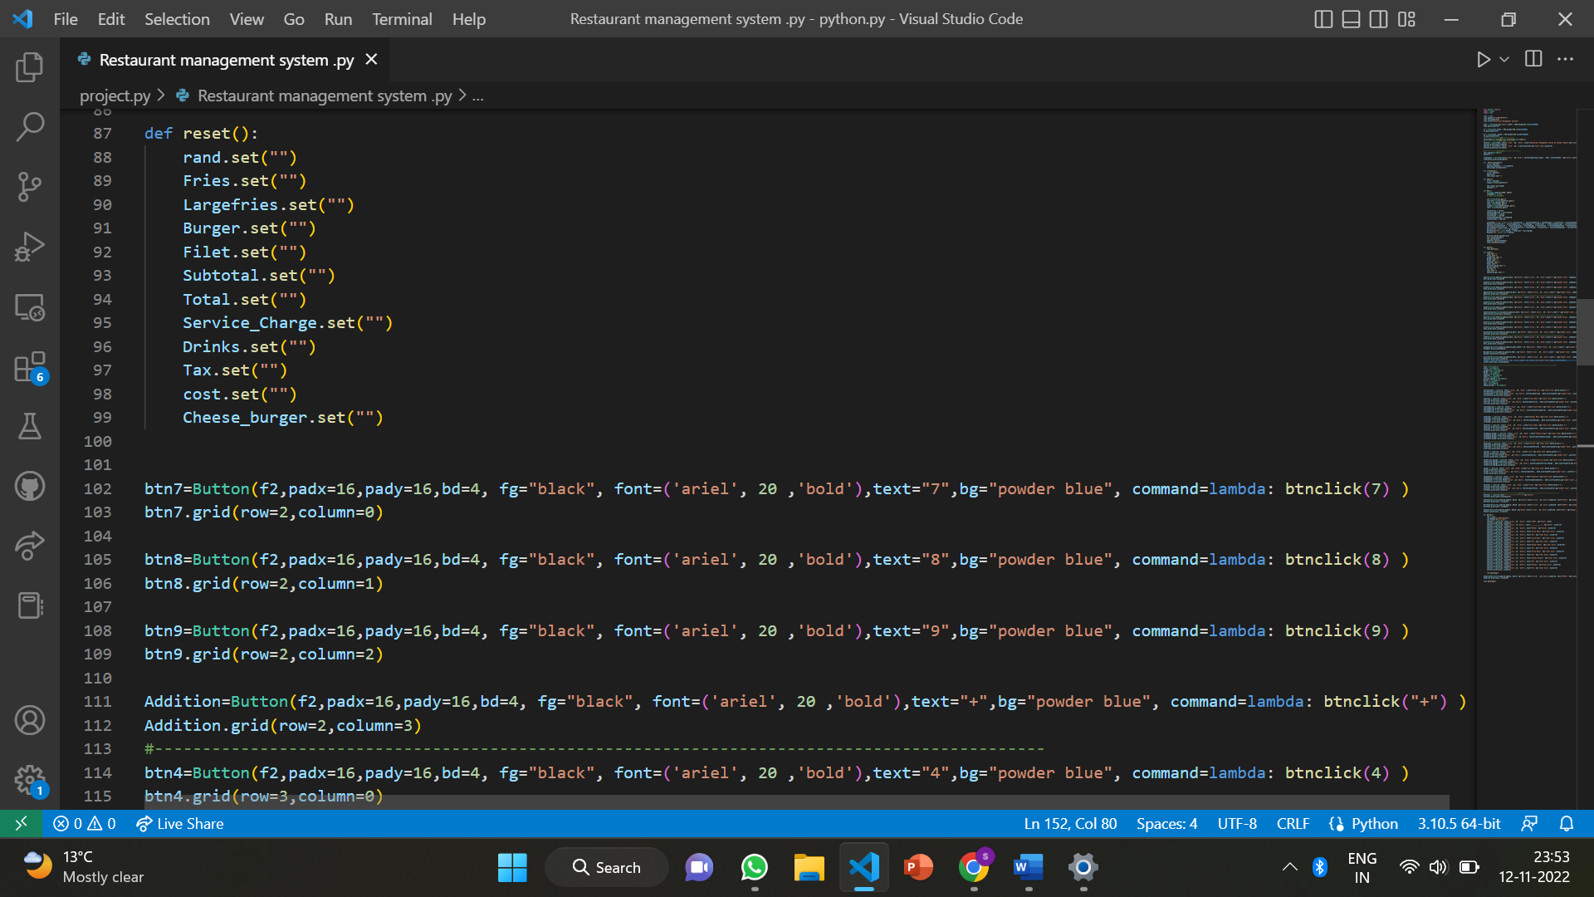

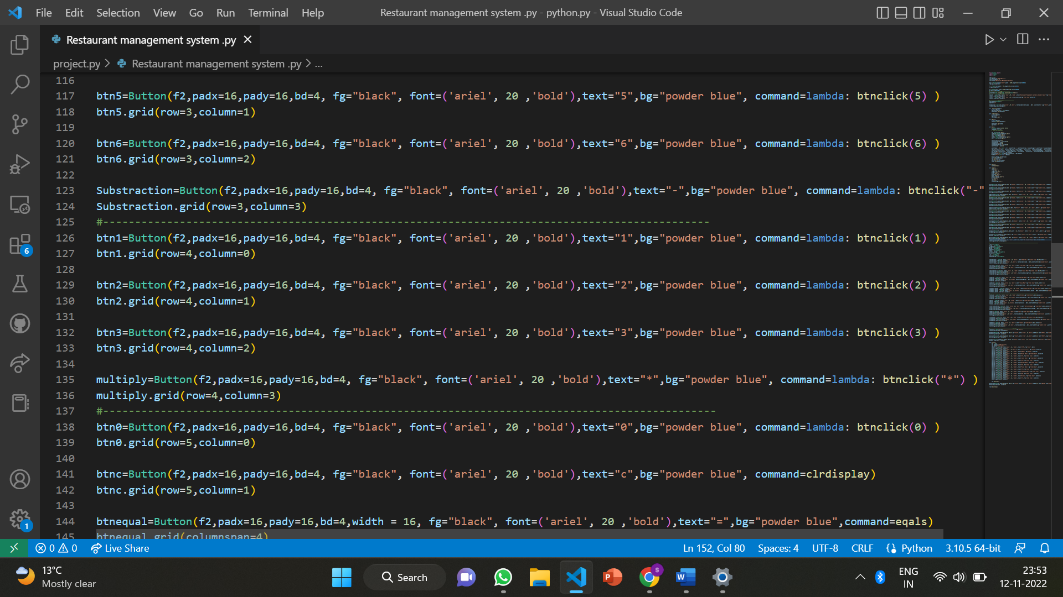

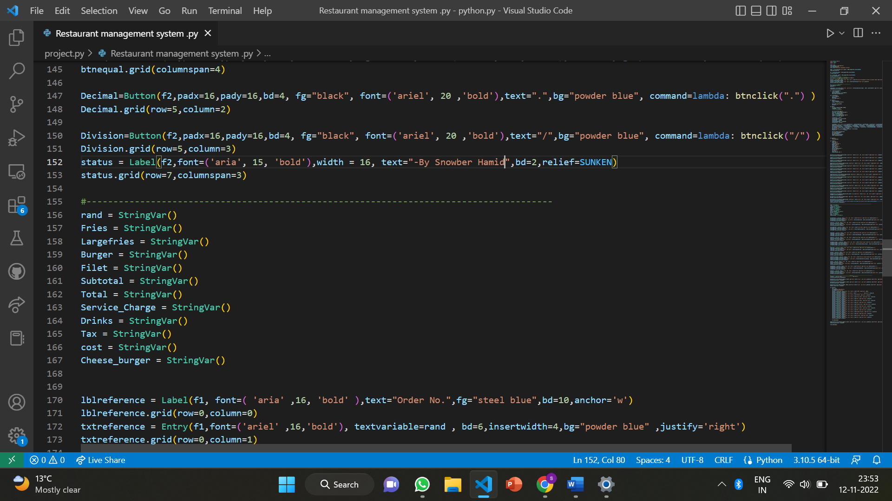

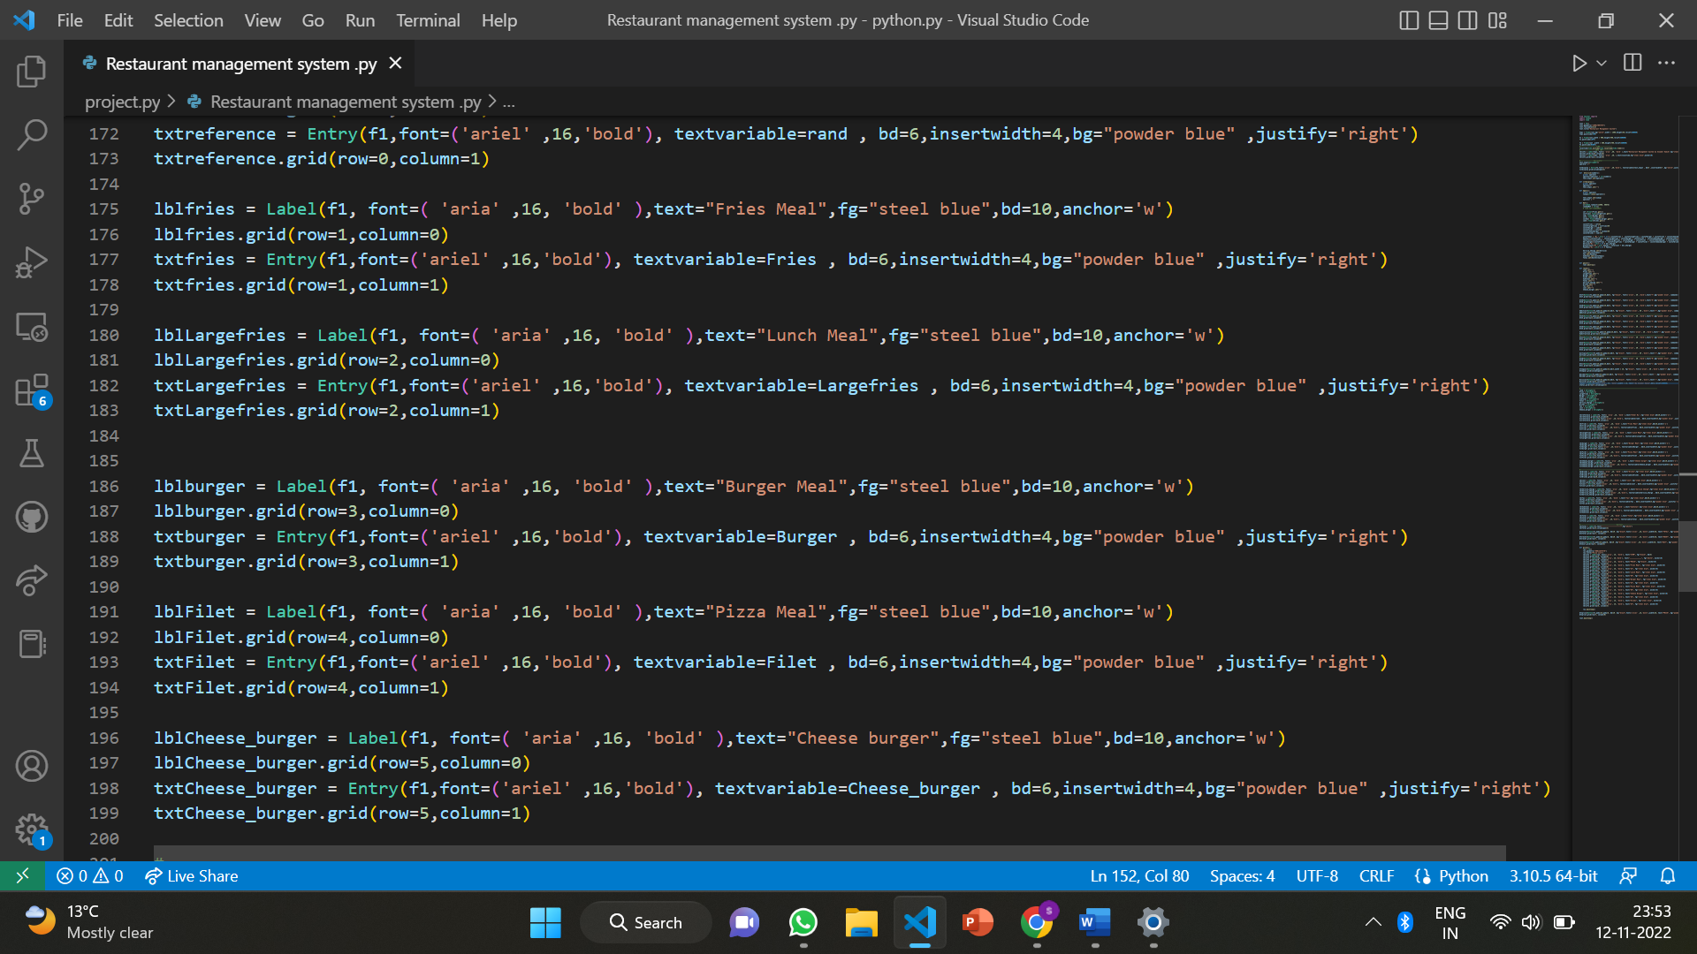

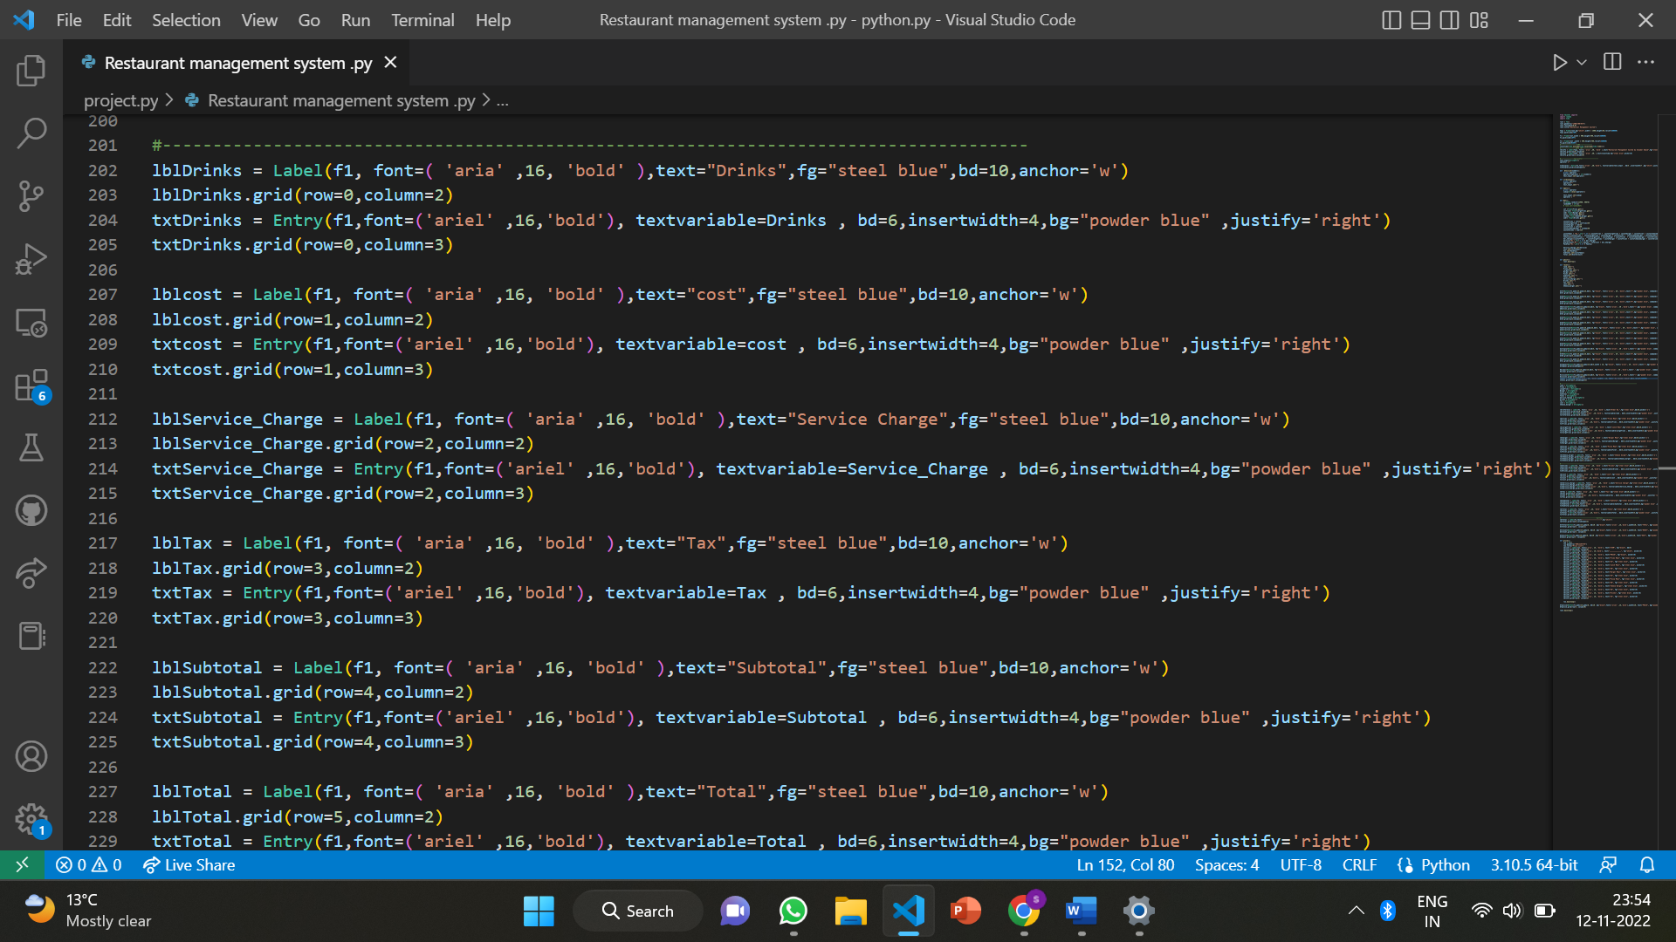

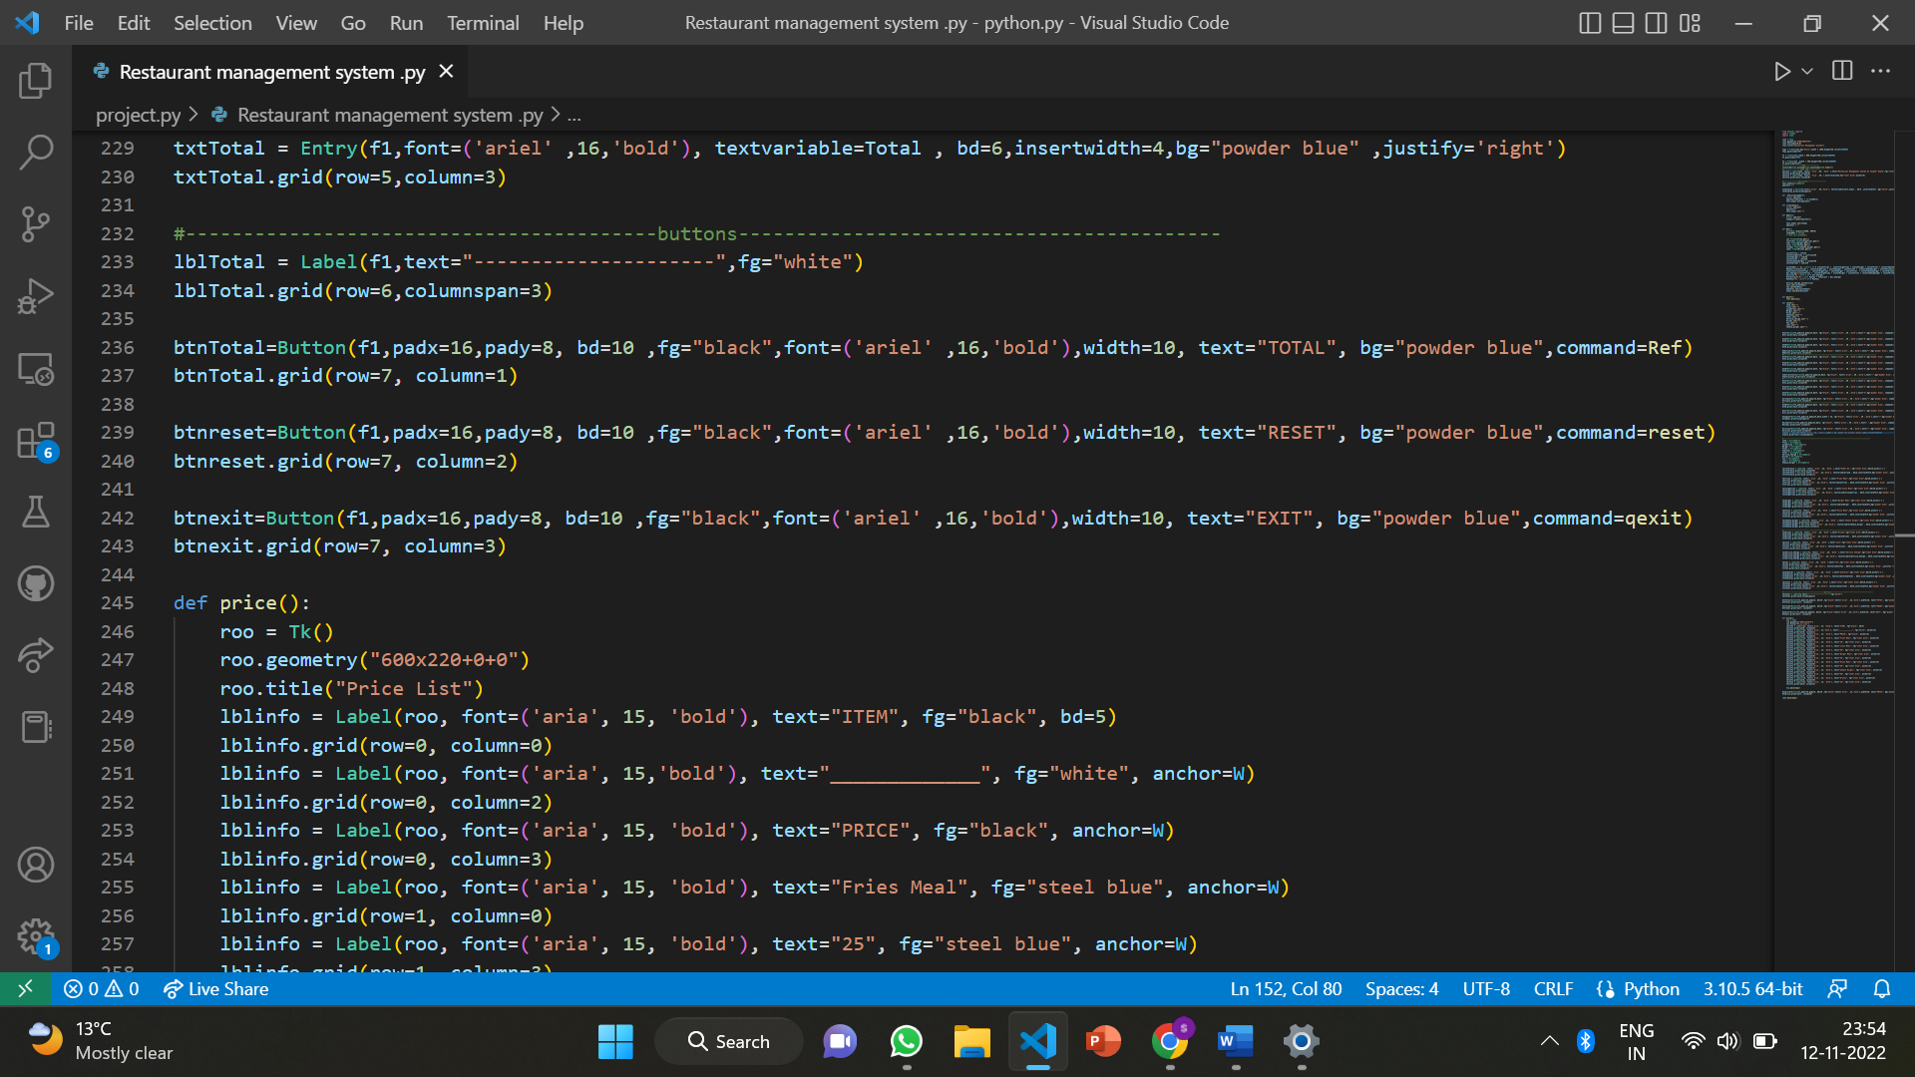

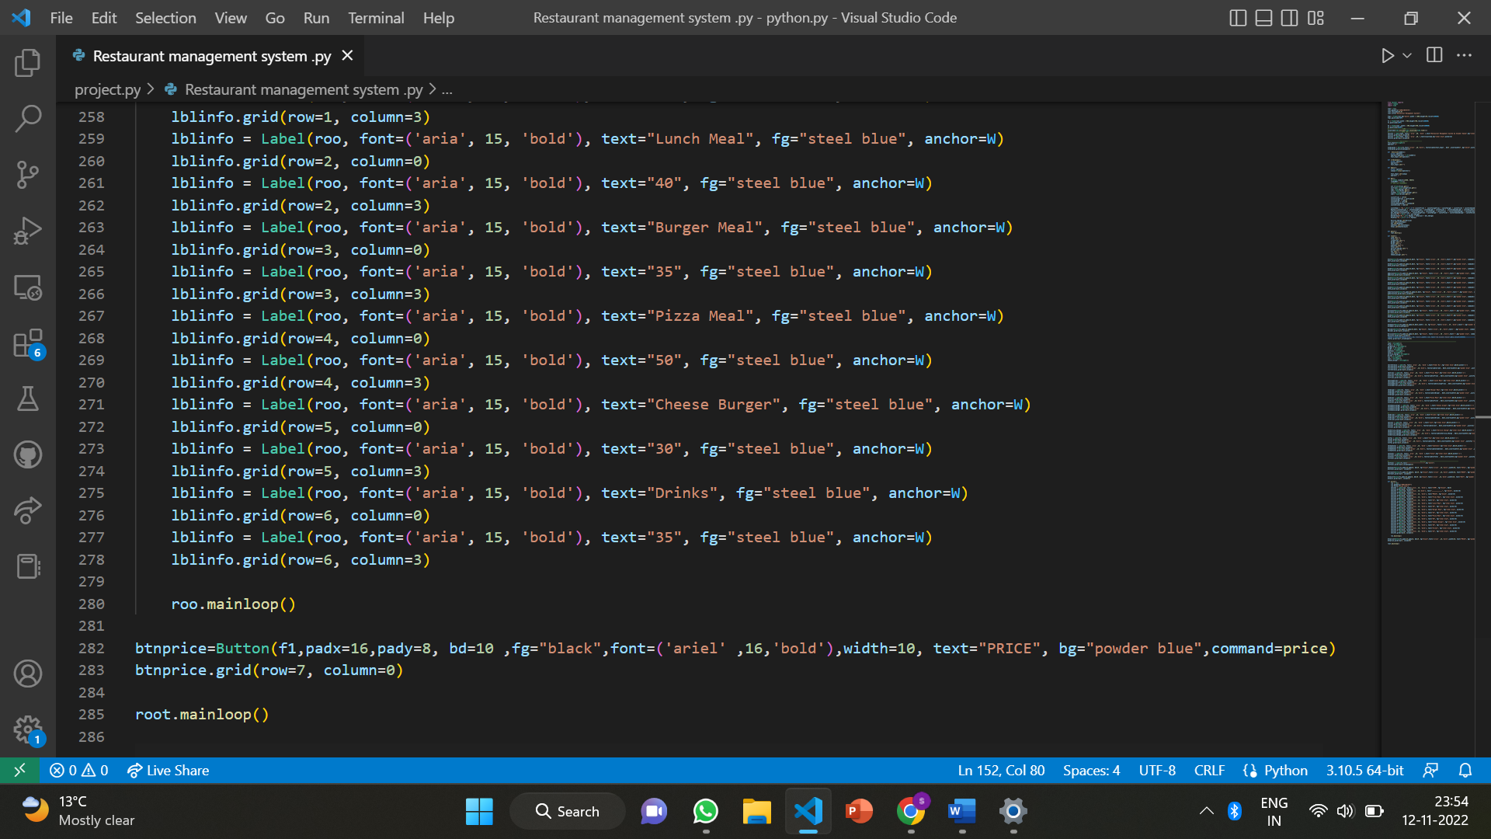

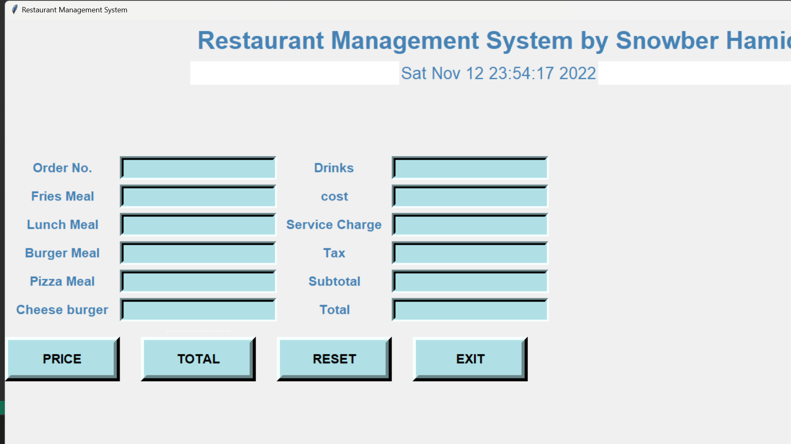

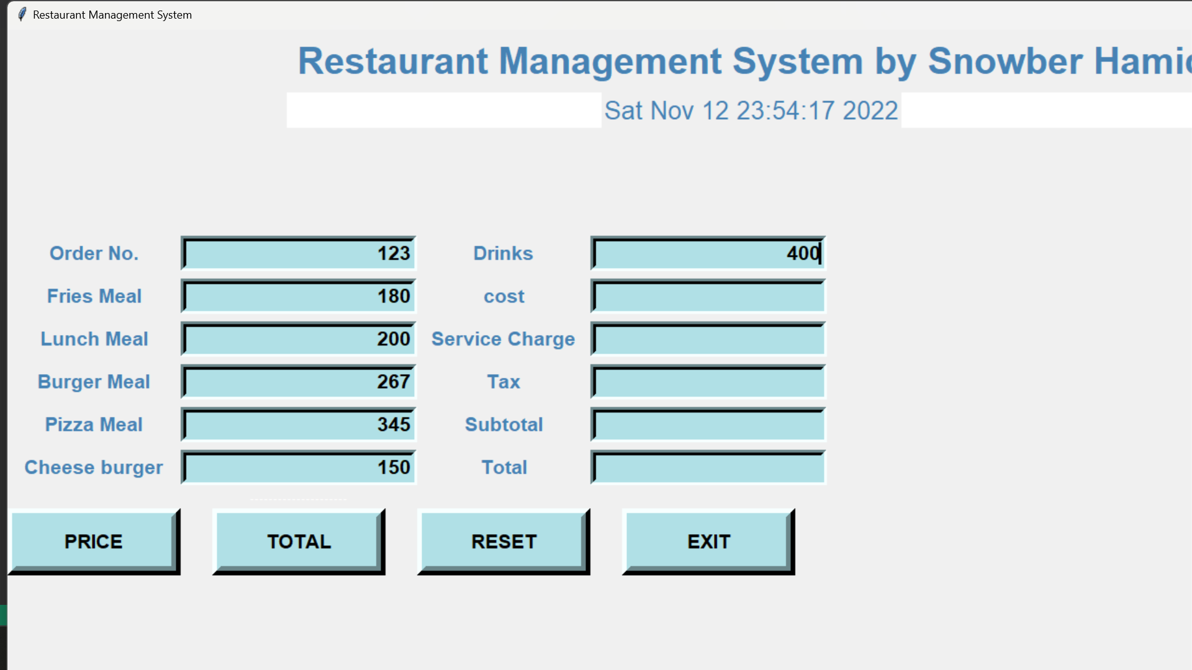

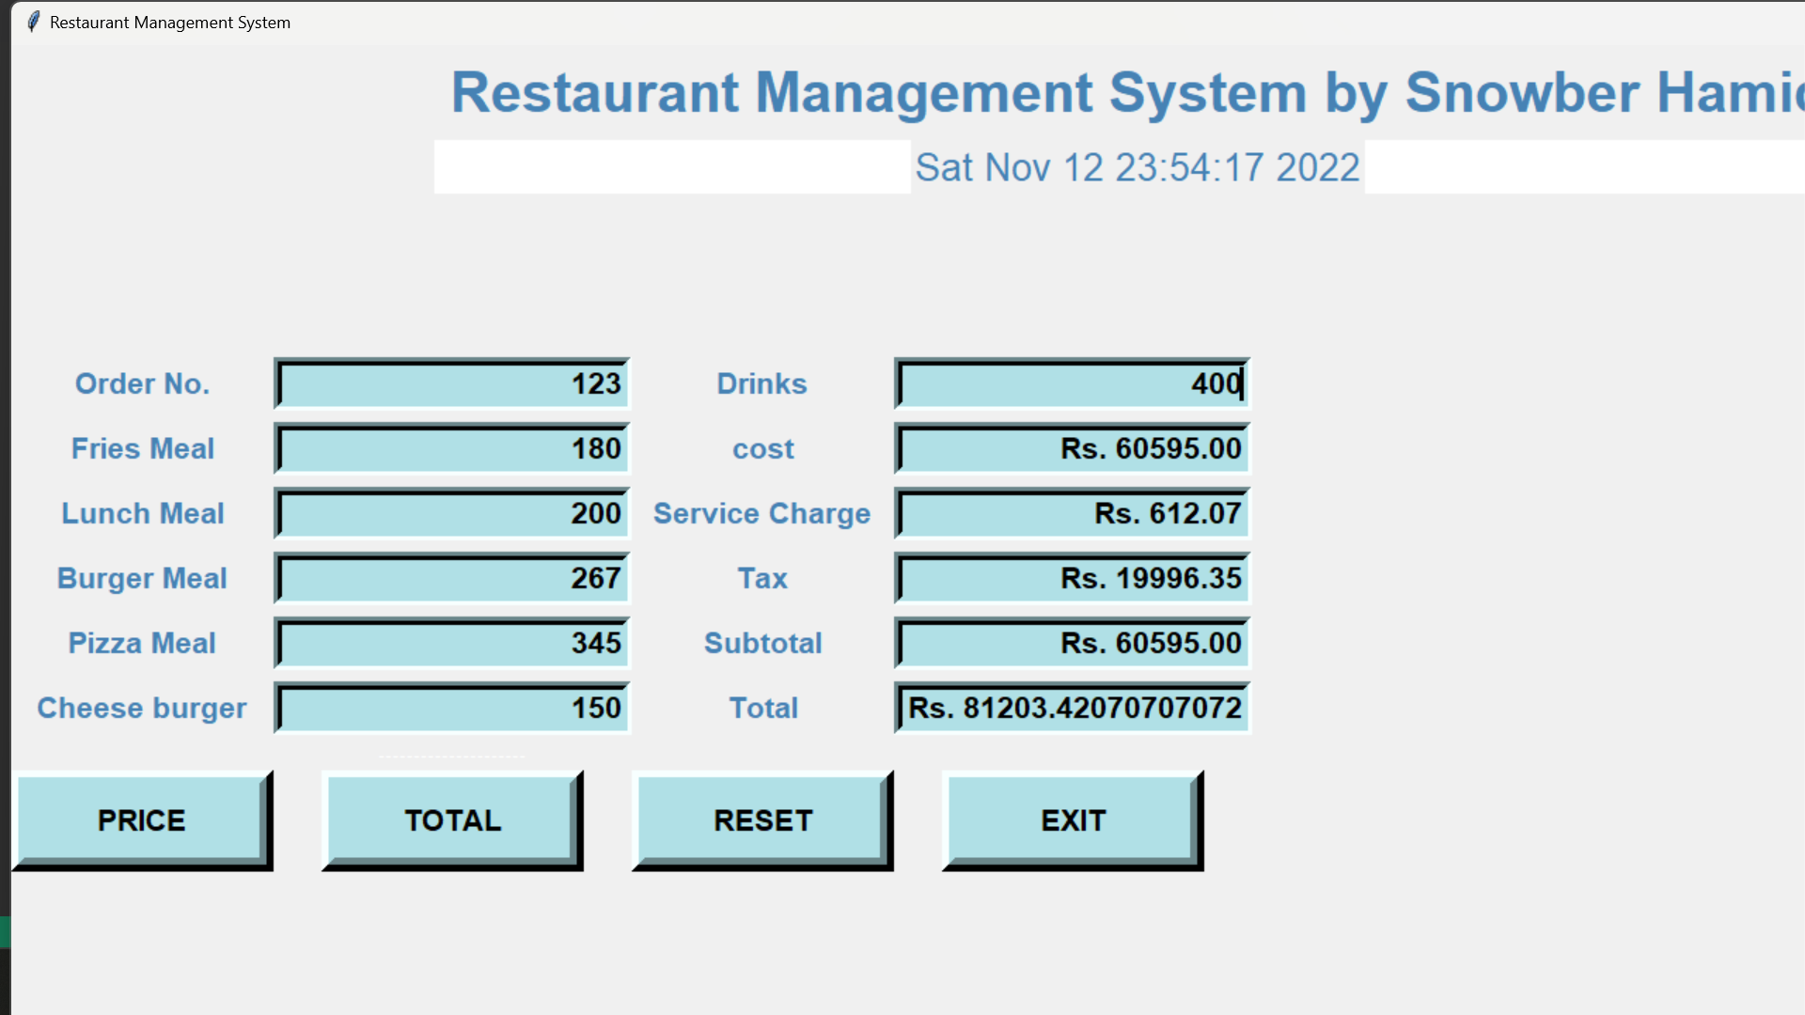

**CHAPTER – 3**

**CONCLUSION**

This project was very informative. I learned a lot from this project. I came through many concepts that I don’t know earlier. As in this project we have worked with Tkinter, which is a standard GUI library in Python. This Tkinter provide various functionalities like buttons, labels, text boxes to build a user – friendly application.

The vast variety of libraries, modules present in python make the life easy for everybody.

Finally, to sum up, I learned a lot while doing this project and gained some experience also. I came across different concepts, different things during the period.

**REFERENCES:**

(1): [https://www.geeksforgeeks.org/introduction-to-python/](https://d.docs.live.net/db91bdd97ac1d02c/Documents/PROFESSIONAL%20INTERNSHIP%20REPORT.docx)

(2): [https://www.geeksforgeeks.org/history-of-python/](https://d.docs.live.net/db91bdd97ac1d02c/Documents/PROFESSIONAL%20INTERNSHIP%20REPORT.docx)

(3): [https://www.simplilearn.com/what-is-python-used-for-article](https://d.docs.live.net/db91bdd97ac1d02c/Documents/PROFESSIONAL%20INTERNSHIP%20REPORT.docx)

(4): [https://rb.gy/ogydhp](https://d.docs.live.net/db91bdd97ac1d02c/Documents/PROFESSIONAL%20INTERNSHIP%20REPORT.docx)

(5): [https://www.interviewbit.com/blog/applications-of-python/](https://d.docs.live.net/db91bdd97ac1d02c/Documents/PROFESSIONAL%20INTERNSHIP%20REPORT.docx)

**References of images:**

fig;(1): [https://rb.gy/frvt58](https://d.docs.live.net/db91bdd97ac1d02c/Documents/PROFESSIONAL%20INTERNSHIP%20REPORT.docx)

fig;(2): [https://rb.gy/th82er](https://d.docs.live.net/db91bdd97ac1d02c/Documents/PROFESSIONAL%20INTERNSHIP%20REPORT.docx)

fig;(3): [https://www.geeksforgeeks.org/history-of-python/](https://d.docs.live.net/db91bdd97ac1d02c/Documents/PROFESSIONAL%20INTERNSHIP%20REPORT.docx)

fig;(4), fig;(5), fig;(6), fig;(7), fig;(8):

[https://www.interviewbit.com/blog/applications-of-python/](https://d.docs.live.net/db91bdd97ac1d02c/Documents/PROFESSIONAL%20INTERNSHIP%20REPORT.docx)

fig;(9): [https://rb.gy/3lchdj](https://d.docs.live.net/db91bdd97ac1d02c/Documents/(2020a1r065)_Snowber_hamid_PROFESSIONAL%20INTERNSHIP%20REPORT.docx)